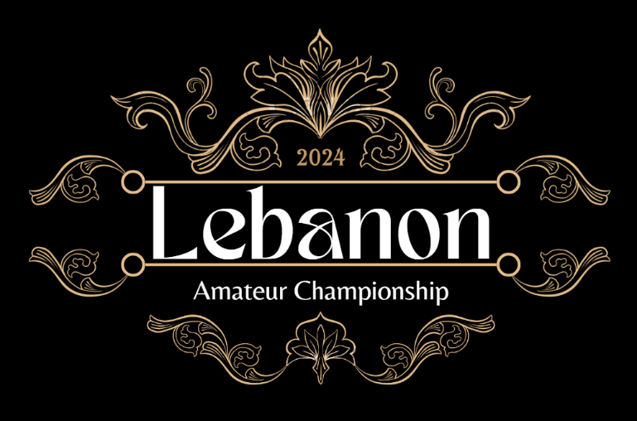

2024 Lebanon Amateur Championship – Sponsorship Form

This document seeks to outline an incredible opportunity to become a financial partner for what will be one of the hallmark events of the year for Lebanon County and the state of Pennsylvania. The Lebanon Amateur Championship is a disc golf tournament seeking to bring together over 350 competitors from across the region to compete at the highest level possible.

Disc golf is a sport that has seen rapid growth around the world, especially within the last 2-3 years. Some of the best courses in the world are right here in Pennsylvania. More specifically, Lebanon County contains numerous courses that are amongst the best in the state and one new course that has the potential to become one of the best in the world. As the sport continues to grow, so does the need for large tournaments and opportunities for players to come together and celebrate the rich history of local disc golf amongst their communities.

Partnering with this tournament not only helps grow disc golf within our community but also helps pour money into the Lebanon economy, strengthening local businesses and supporting all the amateur players coming to the event. In 2021, an event held in Missouri with a similar population to Lebanon County netted an economic impact of roughly $150,000 to the area. Illinois sees a rough economic impact of more than $1 million due to one single event.

The long-term goal is to make this an annual event that grows with time, becoming a “must-attend” event on players' calendars for years to come. The five courses this event will visit are Coleman Memorial Park, South Hills DGC, Lenni Lenape Park, Twin Grove Campground, and Jackson Recreational Park.

Please see the below Sponsorship Details for your review. We have included a variety of sponsorship levels to suit the advertising needs of all interested supporters of this fun and festive event, and we welcome both cash contributions and in-kind donations as detailed below.

Thank you for your consideration,

Lebanon Amateur Championship Team

Who We Are

The Lebanon Amateur Championship Team is comprised of players and tournament directors from a wide range of backgrounds who can agree on one thing, disc golf is awesome! We are looking to bring more light to this great sport and support local clubs, courses, and communities in the process.

Among the members of our group, over 450 sanctioned and another 300+ unsanctioned tournaments, leagues, and special events have been hosted. Each person brings a unique set of experiences as a player or tournament director that are aimed at creating the best possible experience for the participants of this marquee event.

Our members include:

Shawn Conroy Richie Klinger
PDGA # 77900 PDGA # 13217
PDGA State Coordinator for Pennsylvania Assistant Tournament Director
Tournament Director
Marci Klinger
Mike Solt PDGA # 47869
PDGA # 32429 Assistant Tournament Director
Experience Director
Bill Ganley
Mike Snyder PDGA # 69183
PDGA # 104989 Advisor
Assistant Tournament Director
Curvin Stine
Jason Pauley PDGA # 41869
PDGA # 155293 Assistant Tournament Director
Assistant Tournament Director
Gary Daddario
PDGA # 138471
Assistant Tournament Director

Check out the event page here – https://www.discgolfscene.com/tournaments/Lebanon_Amateur_Championship_2024

Come see the website for the event details and news here – http://lebamchamps.com/

Sponsorship Opportunities

EVENT SPONSOR – $5,000 or 18 Disc Golf Baskets & Sleeves

- Your organization will be recognized as the official sponsor of the event and will include the following benefits:
  - Naming rights for the 2024 event
  - Full-page ad in the Caddy Guide
  - Sponsor banner displayed at the players’ party
  - One vending space at players’ party Fly-Mart
  - Company name/logo displayed on the tournament social media pages
  - Company shoutout on all media coverage of the event
  - Sponsor name formally announced at players’ meeting and awards ceremony
  - Invitation to throw the inaugural first shot before play begins

COURSE SPONSOR – $1,000

- Your organization will be recognized as the official sponsor of one of the courses and will include the following benefits:
  - Half-page ad in the Caddy Guide
  - Company name/logo displayed on the “Course Sponsor” banner at the player’s party
  - Company name/logo displayed at the tournament central location of the sponsored course
  - One vending space at players’ party Fly-Mart
  - Company name/logo displayed on the tournament social media pages
  - Company shoutout on all media coverage of the event
  - Sponsor name formally announced at players’ meeting and awards ceremony

PLAYERS’ PARTY SPONSOR – $1,000

- Your organization will be recognized as the official sponsor of the players’ party and will include the following benefits:
  - Half-page ad in the Caddy Guide
  - Company name/logo displayed at the players’ party
  - One vending space at players’ party Fly-Mart
  - Company name/logo displayed on the tournament social media page
  - Company shout out on all media coverage of the event

BEER SPONSOR – $1,000

- Your organization will be recognized as the official beer sponsor of the player’s party and will include the following benefits:
  - Half-page ad in the Caddy Guide
  - Company name/logo displayed at the players’ party
  - One vending space at players’ party Fly-Mart
  - Company name/logo displayed on the tournament social media pages

FLY-MART Vending Spaces – $100

- Enjoy on-site vending during the players’ party with your own dedicated space. For the small one-time fee, you are able to keep all sales and profits from your proceeds. The Fly-Mart will be in operation on Friday during the check-in, players’ party, Putting Championship and Flex event being hosted at Twin Grove Campground.

PUTTING CHAMPIONSHIP SPONSOR – $500

- Amateur players will be tested in a competition of putting prowess to crown the best amateur putter in Central PA!
- Your organization will be recognized at the official sponsor of the putting championship and will include the following benefits:
  - One vending space at players’ party Fly-Mart
  - Company name/logo displayed on the tournament social media pages
  - Company name formally announced during the awards ceremony
  - One vending space at the players’ party Fly-Mart
  - Half-page ad in the Caddy Guide

FLEX EVENT (TWIN GROVE DOUBLES) SPONSOR – $500

- Your organization will be recognized at the official sponsor of the doubles flex event and will include the following benefits:
  - One vending space at players’ party Fly-Mart
  - Company name/logo displayed on the tournament social media pages
  - Company name formally announced during the awards ceremony
  - One vending space at the players’ party Fly-Mart
  - Half-page ad in the Caddie Guide

FLEX EVENT (COLEMAN PARK) SPONSOR – $500

- Your organization will be recognized at the official sponsor of the singles flex event at Coleman Park and will include the following benefits:
  - One vending space at players’ party Fly-Mart
  - Company name/logo displayed on the tournament social media pages
  - Company name formally announced during the awards ceremony
  - One vending space at the players’ party Fly-Mart
  - Half-page ad in the Caddie Guide

FLEX EVENT (SOUTH HILLS) SPONSOR – $500

- Your organization will be recognized at the official sponsor of the putting championship and will include the following benefits:
  - One vending space at players’ party Fly-Mart
  - Company name/logo displayed on the tournament social media pages
  - Company name formally announced during the awards ceremony
  - One vending space at the players’ party Fly-Mart
  - Half-page ad in the Caddie Guide

HOLE SPONSOR – $50

- Your name/organization will be displayed at the tee sign for your hole and will be included in the Caddie Guide as well as shouted out in the media coverage of the hole during coverage.

ADDITIONAL SPONSORSHIP OPPORTUNITIES:

- Contributing Sponsorship – $25
  - Name displayed in the Caddie Guide

- Advertising Solutions:
  - Banner display at course of choice – $250
  - Full page ad space in the Caddie Guide – $100
  - Half-page ad space in the Caddie Guide – $50

- In-kind Sponsorships are welcome for players’ packs or giveaways. Please contact our team to discuss the details.

Next Steps

Please email all sponsorship purchase requests to info@lebamchamps.com. Once requests have been reviewed and approved by the team, an invoice will be created and sent to you for payment.

In addition to cash payments for sponsorships, other forms of payment may be considered by the Organizing Committee, such as merchandise and supplies, on a case-by-case basis. If you have any questions or would like more information about the event or the details in this packet, please contact the email above.

Thank you for your support for the sport of disc golf, our amateur players, and the growth of disc golf in Lebanon County!

